- Regression Test Suite for Ecommerce Application.
Ans) A Regression Test Suite is a collection of test cases specifically curated to be executed whenever the software undergoes a change—such as a new feature addition, a bug fix, or a configuration update.
Its primary purpose is to ensure that the "old" features haven't been accidentally broken by the "new" code. In the industry, this is often referred to as checking for "side effects."

1. What is a Regression Test Suite?
Imagine you have a stable application. You decide to update the "Profile Picture" upload feature. A regression suite ensures that while you were fixing the photo uploader, you didn't accidentally break the "Login" button or the "Save Settings" functionality.
- When to run it: After every code change, patch, or environment update.
- Automation: Because these tests are run repeatedly, the regression suite is the #1 candidate for automation.
- Selection: You don't necessarily run every test ever written. You select a subset that covers the most critical and high-risk areas of the app.

2. Regression Suite for an E-commerce Application
For an e-commerce platform, the regression suite must prioritize the "Money Path"—the sequence of actions that leads to a successful sale. If these fail, the business loses revenue immediately.
A typical suite would include:
A. User Authentication & Profile
- Login/Logout: Can existing users still log in?
- Session Management: Does the user stay logged in while navigating between the home page and the cart?
B. Product Search & Discovery
- Search Functionality: Does searching for "laptop" still return relevant results?
- Filters & Sorting: Do the price filters (Low to High) still work without crashing the page?
- Product Detail Page (PDP): Do images, descriptions, and "Add to Cart" buttons load correctly?
C. Shopping Cart (The Critical Path)
- Add/Remove Items: Can users add a product to the cart and see the count update?
- Price Calculation: Does the cart correctly calculate the subtotal, taxes, and shipping fees?
- Quantity Update: What happens if the user changes the quantity from 1 to 5?
D. Checkout & Payments
- Shipping Info: Can the user enter or select a saved address?
- Payment Gateway: Do saved credit cards or UPI options still process (usually tested in a sandbox environment)?
- Order Confirmation: Does the system generate an Order ID and send a confirmation email/SMS?
E. Promotions & Coupons
- Discount Codes: Does a "10% OFF" coupon still apply correctly to the total?
- Expired Coupons: Does the system correctly reject an expired code?

3. Levels of Regression Testing
Depending on the size of the update, teams usually choose one of three approaches:
Type | When to use | Scope
Unit Regression | After a small bug fix | Tests only the specific module that was changed.
Regional Regression | After a new feature | Tests the changed module + all modules connected to it.
Full Regression | Before a major release | Tests the entire application from start to finish.

- Regression Test Suite for Banking Application
Ans) For a banking application, the Regression Test Suite is arguably even more critical than in e-commerce. While a bug in e-commerce might result in a lost sale, a bug in banking can lead to legal issues, regulatory fines, and a total loss of user trust.
The suite must focus on Accuracy, Security, and Audit Trails.

1. Core Regression Suite for Banking
The regression suite for a bank ensures that fundamental financial logic remains intact after any system update.
A. Account Management
- Balance Accuracy: Does the balance update correctly after a credit or debit? (The most critical check).
- Account Statements: Can users still generate and download PDF statements for specific date ranges?
- Profile Security: Can users change their PIN/Password, and does it correctly invalidate the old session?
B. Fund Transfers (The "Money Path")
- Internal Transfers: Moving money between a user’s own Savings and Current accounts.
- External Transfers (NEFT/IMPS/RTGS): Verifying that adding a new beneficiary still triggers the mandatory cooling-off period.
- Transaction Limits: Does the system still block a transfer that exceeds the daily limit?
C. Bill Payments & Recharges
- Utility Bills: Ensuring integrated services (Electricity, Water, Gas) still fetch the correct "Amount Due."
- Automatic Payments: Verifying that scheduled "Standing Instructions" (like a monthly SIP or Rent) are still triggered on the correct date.
D. Loan & Credit Card Modules
- Interest Calculation: Does the system still calculate the EMI or monthly interest accurately based on the principal?
- Credit Limits: Does a transaction get declined if it exceeds the available credit limit?

2. Specialized Banking Regression Checks
Unlike other apps, banking suites often include "Hidden" regression checks that don't involve the UI.
- Audit Logging: Every time a user logs in or moves money, the system must record a log. Regression testing ensures that these logs are still being generated correctly for compliance.
- Concurrency Testing: What happens if a user tries to withdraw money from an ATM and transfer money via the app at the exact same second? The regression suite often includes checks for "Race Conditions."
- Data Integrity: Ensuring that sensitive data (like Account Numbers) remains masked ($XXXX-XXXX-1234$) in the UI after an update.

3. Comparison: E-Commerce vs. Banking Regression
Feature | E-Commerce Regression | Banking Regression
Primary Goal | Conversion & Sales | Accuracy & Security
Critical Failure | "I can't buy this shirt." | "My balance is showing zero."
Data Sensitivity | Medium (Addresses/Preferences) | High (Financial Records/KYC)
Regulation | Consumer Protection Laws | RBI / Central Bank Compliance

4. Example Scenario: Applying a Security Patch
If your team at Cognizant is tasked with updating the login encryption for a banking client:
- The Change: Upgrade from RSA to a stronger encryption method.
- The Regression Suite: You wouldn't just test the login. You would run the Full Regression Suite to ensure that the new encryption hasn't slowed down the "Transfer Money" API or caused the "Mobile OTP" service to timeout.

- Sample Test Cases for Common Features
6.4.1 Login Test Cases
TC ID | Title | Steps | Test Data | Expected Result
TC_LOGIN_001 | Valid login | 1. Go to login page 2. Enter email 3. Enter password 4. Click Login | email: valid@test.com, pwd: Valid@123 | Redirect to dashboard
TC_LOGIN_002 | Invalid email format | 1. Go to login page 2. Enter invalid email 3. Click Login | email: invalidformat | Error: "Invalid email format"
TC_LOGIN_003 | Wrong password | 1. Go to login page 2. Enter valid email 3. Enter wrong password 4. Click Login | email: valid@test.com, pwd: WrongPwd | Error: "Invalid credentials"
TC_LOGIN_004 | Empty email | 1. Go to login page 2. Leave email empty 3. Enter password 4. Click Login | email: (empty), pwd: Valid@123 | Error: "Email is required"
TC_LOGIN_005 | Empty password | 1. Go to login page 2. Enter email 3. Leave password empty 4. Click Login | email: valid@test.com, pwd: (empty) | Error: "Password is required"
TC_LOGIN_006 | Account locked | 1. Enter wrong password 3 times | email: valid@test.com | Error: "Account locked. Contact support"
TC_LOGIN_007 | Remember me | 1. Login with Remember Me checked 2. Close browser 3. Reopen app | - | User should stay logged in
TC_LOGIN_008 | SQL injection | 1. Enter malicious input | email: ' OR '1'='1 | Error: "Invalid email format"
TC_LOGIN_009 | Case sensitivity | 1. Enter email in uppercase | email: VALID@TEST.COM | Should work (email case-insensitive)
TC_LOGIN_010 | Password visibility | 1. Enter password 2. Click eye icon | - | Password should toggle visible/hidden
6.4.2 Signup/Registration Test Cases
TC ID | Title | Steps | Test Data | Expected Result
TC_REG_001 | Successful registration | 1. Go to signup page 2. Enter all valid details 3. Click Register | All valid data | Success message, verification email sent
TC_REG_002 | Duplicate email | 1. Try registering with existing email | email: existing@test.com | Error: "Email already registered"
TC_REG_003 | Password mismatch | 1. Enter different passwords | pwd: Pass@123, confirm: Pass@456 | Error: "Passwords don't match"
TC_REG_004 | Weak password | 1. Enter password without special char | pwd: password123 | Error: "Password needs special character"
TC_REG_005 | Invalid phone | 1. Enter letters in phone field | phone: abcdefghij | Error: "Invalid phone number"
TC_REG_006 | Future birthdate | 1. Select future date | dob: 2025-12-31 | Error: "Invalid date of birth"
TC_REG_007 | Terms not accepted | 1. Fill form without checking terms 2. Click Register | - | Error: "Accept terms to continue"
TC_REG_008 | Email verification | 1. Register 2. Check email | - | Verification email received within 5 minutes
6.4.3 Search Test Cases
TC ID | Title | Steps | Test Data | Expected Result
TC_SEARCH_001 | Valid search | 1. Enter search term 2. Click Search | query: "laptop" | Relevant results displayed
TC_SEARCH_002 | No results | 1. Search non-existent term | query: "xyzabc123" | "No results found" message
TC_SEARCH_003 | Empty search | 1. Click search without entering text | query: (empty) | Error or show all results
TC_SEARCH_004 | Special characters | 1. Enter special characters | query: "@#$%^&" | Handle gracefully, no crash
TC_SEARCH_005 | Case insensitive | 1. Search in uppercase | query: "LAPTOP" | Same results as "laptop"
TC_SEARCH_006 | Partial match | 1. Enter partial word | query: "lap" | Results containing "lap" shown
TC_SEARCH_007 | Search suggestions | 1. Type slowly | query: "pho" | Suggestions: phone, photo, etc.
TC_SEARCH_008 | Search with filters | 1. Search "laptop" 2. Filter by price | query: "laptop", price: $500-$1000 | Filtered results
6.4.4 Dropdown Test Cases
TC ID | Title | Steps | Test Data | Expected Result
TC_DROP_001 | Select single option | 1. Click dropdown 2. Select option | selection: "Option 1" | Option selected, dropdown closes
TC_DROP_002 | Default value | 1. Load page with dropdown | - | Default value displayed
TC_DROP_003 | All options visible | 1. Click dropdown | - | All options visible in list
TC_DROP_004 | Search in dropdown | 1. Type in searchable dropdown | search: "Ind" | Filtered options: India, Indonesia
TC_DROP_005 | Keyboard navigation | 1. Tab to dropdown 2. Use arrow keys | - | Options navigable via keyboard
TC_DROP_006 | Clear selection | 1. Select option 2. Click clear | - | Selection cleared
TC_DROP_007 | Multi-select | 1. Select multiple options | - | All selected options shown
TC_DROP_008 | Disabled options | 1. Try selecting disabled option | - | Cannot select disabled options
6.4.5 Pagination Test Cases
TC ID | Title | Steps | Test Data | Expected Result
TC_PAGE_001 | First page | 1. Load list page | - | First 10 items displayed
TC_PAGE_002 | Next page | 1. Click "Next" | - | Next 10 items displayed
TC_PAGE_003 | Previous page | 1. Go to page 3 2. Click "Previous" | - | Page 2 items displayed
TC_PAGE_004 | Specific page | 1. Click page number 5 | - | Page 5 items displayed
TC_PAGE_005 | Last page | 1. Click "Last" | - | Last page items displayed
TC_PAGE_006 | Items per page | 1. Change from 10 to 50 | - | 50 items per page displayed
TC_PAGE_007 | Page info | 1. Navigate pages | - | "Showing 11-20 of 100" displayed
TC_PAGE_008 | Empty last page | 1. If only 15 items, go to page 2 | items_per_page: 10 | Page 2 shows 5 items
6.4.6 Form Validation Test Cases

TC ID | Title | Steps | Test Data | Expected Result
TC_FORM_001 | All fields valid | 1. Fill all fields correctly 2. Submit | All valid | Form submitted successfully
TC_FORM_002 | Required field empty | 1. Leave required field empty 2. Submit | name: (empty) | Error: "Name is required"
TC_FORM_003 | Max length exceeded | 1. Enter 101 chars in 100-char field | name: 101 characters | Error: "Maximum 100 characters allowed"
TC_FORM_004 | Invalid format | 1. Enter invalid email | email: invalid | Error: "Invalid email format"
TC_FORM_005 | Tab order | 1. Press Tab through fields | - | Fields focused in correct order
TC_FORM_006 | Error clearing | 1. Fix error 2. Re-submit | - | Error message clears
TC_FORM_007 | Inline validation | 1. Type invalid data 2. Leave field | - | Error shows immediately
TC_FORM_008 | Form reset | 1. Fill form 2. Click Reset | - | All fields cleared

7.6 Database Validation Basics
Verifying Data in Database:
TC ID | Scenario | SQL Query | Validation
TC_DB_001 | User created | SELECT * FROM users WHERE email = 'new@test.com' | Record exists
TC_DB_002 | Correct data | SELECT name, email FROM users WHERE id = 1 | Name = 'John', Email = 'john@test.com'
TC_DB_003 | Timestamp | SELECT created_at FROM orders WHERE id = 100 | Timestamp is current
TC_DB_004 | Foreign key | SELECT * FROM orders WHERE user_id = 999 | Links to valid user
TC_DB_005 | Cascade delete | DELETE FROM users WHERE id = 1; SELECT * FROM orders WHERE user_id = 1 | Related orders deleted
TC_DB_006 | Unique constraint | INSERT duplicate email | Error: Duplicate entry
Common SQL for Testers:
-- Select all records
SELECT * FROM users;

-- Select with condition
SELECT * FROM orders WHERE status = 'pending';

-- Count records
SELECT COUNT(*) FROM products WHERE price > 100;

-- Join tables
SELECT users.name, orders.total
FROM users
JOIN orders ON users.id = orders.user_id;

-- Check data after insert
SELECT * FROM users WHERE email = 'test@example.com';

-- Verify update
SELECT updated_at FROM products WHERE id = 5;

-- Check delete
SELECT * FROM users WHERE id = 10; -- Should return 0 rows

7.7 File Uploading testcases
Test Case ID | Description | Input/Action | Expected Result
FU_01 | Valid File Upload | Upload a .pdf or .jpg under the size limit. | File uploads successfully; success message appears.
FU_02 | File Size Limit (BVA) | Upload a file exactly at the maximum limit (e.g., 5MB). | File uploads successfully.
FU_03 | Exceed Size Limit | Upload a file larger than the limit (e.g., 5.1MB). | Upload blocked; "File too large" error appears.
FU_04 | Invalid Format | Upload a .exe or .zip file. | System rejects file with "Invalid format" error.
FU_05 | Empty File | Upload a file with 0 KB size. | System shows an error or ignores the upload.
FU_06 | Special Characters | Upload a file named my#file%2026.png. | System handles the name or renames it safely.

7.8 Sorting testcases
Test Case ID | Description | Input/Action | Expected Result
SRT_01 | Ascending Sort | Click "Sort by Name (A-Z)". | Records reorder alphabetically from A to Z.
SRT_02 | Descending Sort | Click "Sort by Price (High to Low)". | Highest price appears first; lowest last.
SRT_03 | Numeric Sorting | Sort a list of numbers: 9, 10, 80. | 9 appears before 10 (not lexicographical 10, 80, 9).
SRT_04 | Empty State | Apply sorting on a list with 0 items. | No crash; system displays "No data found."
SRT_05 | Pagination + Sort | Sort on Page 1 of a multi-page table. | Entire dataset is sorted, not just the visible page.
SRT_06 | Identical Values | Sort a list where multiple items have the same price. | Items with same price are grouped; secondary sort applies.

7.9 Date Picker testcases

Test Case ID | Description | Input/Action | Expected Result
DT_01 | Today's Date | Select the current date from the widget. | Date is populated in the correct format (e.g., MM/DD/YYYY).
DT_02 | Manual Entry | Type "02/30/2026" manually into the field. | System rejects the date as invalid (February doesn't have 30 days).
DT_03 | Future Date Restriction | For a "Date of Birth" field, select a future year. | System blocks selection or shows validation error.
DT_04 | Leap Year Check | Select "02/29/2024" vs "02/29/2026". | 2024 is accepted; 2026 is rejected/unavailable.
DT_05 | Range Selection | Select a "Start Date" after the "End Date". | System shows error "End date cannot be before start date."
DT_06 | Format Consistency | Pick a date and check the DB/API. | Ensure date is saved in ISO format (YYYY-MM-DD) regardless of UI view.

- How to raise defect in Jira?
Ans) Raising a defect (often called a "Bug" or "Issue") in Jira is a critical part of the Test Execution phase in the STLC. Since you’ll be starting at Cognizant soon, mastering this is essential as Jira is their primary tool for project management.
Here is the step-by-step process to raise a high-quality defect:

1. The Basic Steps in Jira
- Click "Create": Look for the blue "Create" button in the top navigation bar.
- Select Project: Ensure you are in the correct project (e.g., "BookedIn" or "Client_Banking_App").
- Issue Type: Select "Bug" or "Defect" from the dropdown menu.
- Fill in the Details: This is where the quality of your report matters (see the "Anatomy" section below).
- Priority/Severity: Assign how urgent the fix is.
- Click "Create": The bug is now live in the backlog for developers to see.

2. Anatomy of a Perfect Defect Report
A well-written bug reduces "back-and-forth" communication between you and the developer.
A. Summary (Title)
Keep it concise but descriptive.
- Bad: "File upload not working."
- Good: "[File Upload] App crashes when uploading a .png file larger than 5MB."
B. Description
This is the heart of the defect. It should include:
- Steps to Reproduce: Numbered list of exactly how to trigger the bug.
  - Login to the app.
  - Go to Profile Settings.
  - Click "Upload Profile Picture."
  - Select a 6MB .png file.
- Expected Result: "System should show a 'File too large' error message."
- Actual Result: "The application freezes and the browser tab crashes."
C. Environment
Specify where the bug happened to help the dev replicate it.
- OS: Windows 11 / macOS / Android 14.
- Browser: Chrome v123.
- URL/Build: Staging Environment (URL link) or Build Version 1.0.4.
D. Attachments
Always provide proof. * Screenshots: Highlight the error message or the broken UI element.
- Screen Recordings: For complex workflow bugs.
- Log Files: If you are testing backend/APIs, attach the error logs.

3. Severity vs. Priority
You will need to set these fields in Jira.
- Severity (Impact on System): Is the system dead (Critical), or is it just a typo (Low)?
- Priority (Urgency for Business): Does this need to be fixed in the next hour (P1) or can it wait until next month (P4)?
Case | Severity | Priority
App crashes on Login | High | High
Company logo is slightly blurry | Low | Low
"Terms of Service" link is broken | Low | High (Legal Risk)

4. Linking to Requirements
In Jira, you should "Link" your bug to the original User Story or Requirement. This ensures Traceability, which is a big part of your Test Design. It helps the team see that "User Story #101" is currently blocked because of this specific defect.

- What is Severity and Priority explain all the four scenarios with examples.
Ans)
In software testing, Severity and Priority are the two primary scales used to categorize a defect. While they sound similar, one is a technical measure and the other is a business measure.

1. The Definitions
Severity (Technical Impact)
- What it is: How much the bug affects the software's functionality or architecture.
- Who decides: The Tester or QA Engineer.
- Levels: S1 (Critical/Blocker), S2 (Major), S3 (Minor), S4 (Trivial).
Priority (Business Urgency)
- What it is: How quickly the bug needs to be fixed based on business needs, deadlines, or user experience.
- Who decides: The Product Manager or Lead.
- Levels: P1 (High/Immediate), P2 (Medium), P3 (Low).

2. The Four Combinations (With Scenarios)
To master this for your role at Cognizant, you need to understand how these two scales intersect.
A. High Severity & High Priority (S1, P1)
The system is broken, and it must be fixed immediately. These bugs stop all testing and prevent users from using the core product.
- Scenario: On your BookedIn app, the "Login" button causes the entire website to crash (White Screen of Death).
- Why: It’s technically critical (no one can use it) and business-critical (loss of users).
B. High Severity & Low Priority (S1, P3)
The bug is technically massive, but it occurs in a place where no one goes, or it’s on a legacy version that is being phased out.
- Scenario: In a Banking App, the "Export to CSV" function crashes if you try to export data from the year 1995.
- Why: Crashing is a high severity, but since almost no one is exporting 30-year-old data today, the business can wait to fix it.
C. Low Severity & High Priority (S4, P1)
The bug doesn't break any code, but it looks terrible for the brand or causes legal/marketing issues.
- Scenario: On the landing page of the Cognizant corporate site, the company name is misspelled as "Corgnizant."
- Why: It’s just a typo (Low Severity—the site works fine), but it’s a huge embarrassment (High Priority—needs an instant fix).
D. Low Severity & Low Priority (S4, P3)
Cosmetic bugs in non-critical areas.
- Scenario: In the "About Us" section of an app, the font size of the copyright text is 10px instead of 12px.
- Why: It doesn't break anything, and most users won't even notice. It can be fixed in a future update.

3. Comparison Table
Feature | Severity | Priority
Perspective | Technical / Functional | Business / Scheduling
Focus | How bad is the bug? | How soon do we fix it?
Determined by | Quality Assurance (QA) | Product Owner / Manager
Driving Factor | System stability and requirements | Deadlines and User Impact

4. Why this matters in STLC
As you move into the Defect Life Cycle in Jira, these values determine the SLA (Service Level Agreement).
- An S1/P1 bug usually requires developers to drop everything and work on a fix immediately (often within 4-8 hours).
- An S4/P3 bug might sit in the "Backlog" for months.

- Explain about agile.
Ans) Agile is a mindset and a set of practices designed to deliver software in small, incremental "chunks" rather than one massive release. Since you are joining Cognizant, you will almost certainly work in a Scrum framework, which is the most popular way to implement Agile.

1. Key Agile Roles
In an Agile team (often called a "Squad"), everyone has a specific purpose:
- Product Owner (PO): Represents the customer. They decide what needs to be built and prioritize the work.
- Scrum Master: The "Coach." They ensure the team follows Agile principles, remove blockers, and facilitate meetings.
- Development Team: The people doing the work (Developers, Testers, Designers). In your case, as a Programmer Analyst, you are part of this group.

2. The Artifacts (Agile "Documents")
Agile avoids 100-page manuals. Instead, it uses these dynamic tools:
- Product Backlog: A master "To-Do" list of every feature, bug fix, and requirement for the entire project.
- User Story: A requirement written from the user's perspective.
  - Example: "As a book lover, I want to filter books by genre so that I can find my next read faster."
- Sprint Backlog: A subset of the Product Backlog. These are the specific tasks the team commits to finishing in the current 2-week cycle.
- Increment: The "Definition of Done." It is the actual usable piece of software produced at the end of a Sprint (e.g., the newly finished "Sorting" feature).

3. The Agile Workflow (The Scrum Rituals)
The workflow moves in a continuous loop called a Sprint (usually 1 to 4 weeks long).
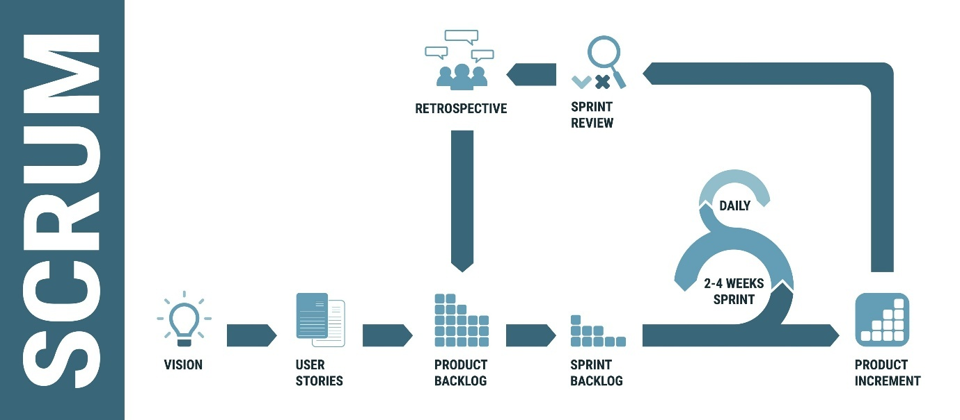
Shutterstock
Step 1: Sprint Planning
The team meets to decide which User Stories from the Product Backlog they can realistically complete.
- Example: For your BookedIn project, you might plan to finish the "Login" and "Book Search" stories this Sprint.
Step 2: Daily Stand-up (Daily Scrum)
A 15-minute daily meeting where everyone answers three questions:
- What did I do yesterday?
- What will I do today?
- Are there any blockers (impediments)?
Step 3: Sprint Review
At the end of the Sprint, the team demos the working software to stakeholders (the client or PO).
- Example: You show the client the working "Book Search" functionality you built.
Step 4: Sprint Retrospective
The team meets privately to discuss how to improve their process.
- Focus: "What went well?" and "What can we do better next time?" (e.g., "We need to write better test cases for the File Upload feature").

4. Measuring Progress
Agile teams don't just use deadlines; they use data:
- Story Points: A measure of the effort required to finish a story (often using the Fibonacci sequence: 1, 2, 3, 5, 8).
- Velocity: The average number of Story Points a team completes per Sprint.
- Burndown Chart: A graph showing how much work is left versus time remaining in the Sprint.
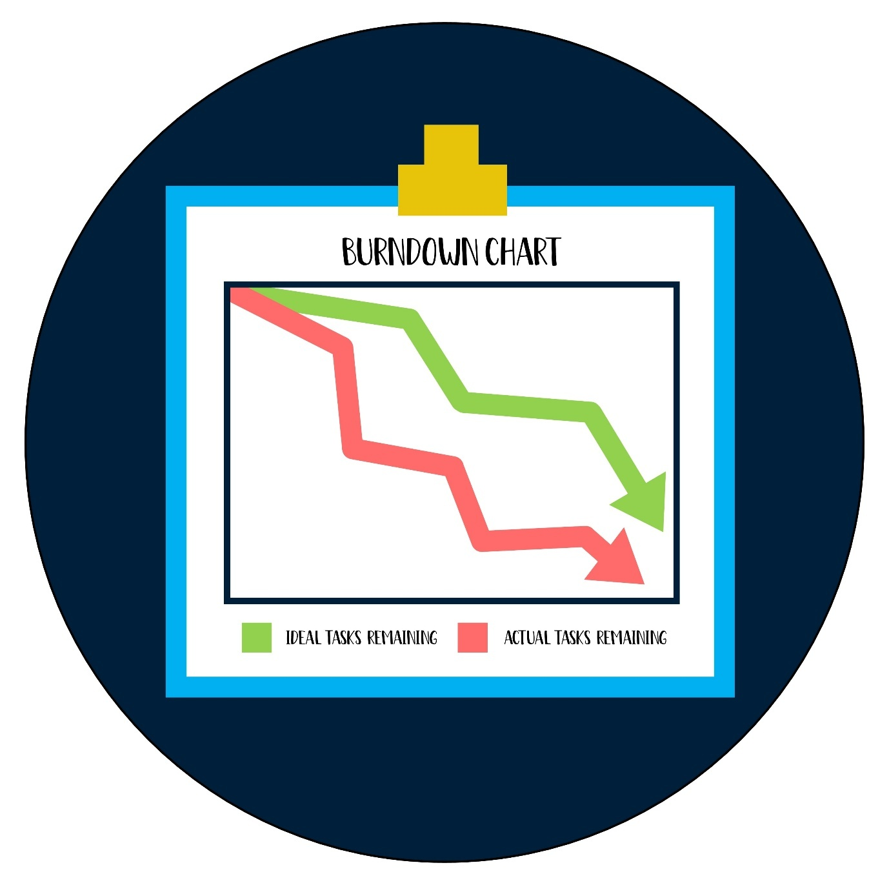
Shutterstock

5. Agile vs. Waterfall: A Practical Example
Imagine you are building a Banking App for Cognizant:
- Waterfall Way: You spend 6 months gathering requirements, 6 months coding, and 3 months testing. You show the app to the bank after 15 months. If they hate the UI, you've wasted a year.
- Agile Way: In the first 2 weeks, you build only the Login screen. You show it to the bank. They say, "We want biometrics instead of passwords." You change it immediately. You deliver value every 2 weeks.

Summary of Terms
Term | Analogy
Epic | A large project (e.g., "Develop the Payment Module").
User Story | A small task within the Epic (e.g., "Pay via UPI").
Sprint | A 2-week race to finish specific tasks.
Backlog | The "Bucket" of all future work.
Scrum Master | The referee who keeps the game moving fairly.

Scrum Ceremonies
In Scrum, "Ceremonies" are the four formal meetings that create a regular cadence for the team. They are designed to ensure transparency, inspection, and adaptation.
1. Sprint Planning
- Purpose: To define what can be delivered in the upcoming Sprint and how that work will be achieved.
- Outcome: The Sprint Backlog (a list of stories the team commits to) and a Sprint Goal.
- Role of Tester: Help estimate Story Points from a testing perspective. They ask, "How complex is this to verify?" and ensure each story has clear Acceptance Criteria.
2. Daily Stand-up (Daily Scrum)
- Purpose: A 15-minute "sync" for the Development Team to align on the next 24 hours.
- The Three Questions: What did I do yesterday? What will I do today? Are there any blockers?
- Role of Tester: Report on testing progress, mention if the test environment is down, or if a "Blocker" bug is stopping them from finishing a story.
3. Sprint Review
- Purpose: To demo the "Increment" (working software) to the Product Owner and stakeholders.
- Outcome: Feedback on the feature and potential new items for the Product Backlog.
- Role of Tester: Often the one demonstrating the feature, or ensuring the demo follows the user's path to show that the feature actually works as intended.
4. Sprint Retrospective
- Purpose: To look back at the process and identify ways to improve teamwork and quality.
- Outcome: A few actionable items to try in the next Sprint (e.g., "Let's automate the login test to save time").
- Role of Tester: Suggest improvements in the testing pipeline, like "We need more time for regression testing at the end of the Sprint."

The Role of a Tester in Agile
In traditional models (Waterfall), testers were the "final gatekeepers" at the very end. In Agile, testing is continuous. You don't wait for the code to be finished; you start on Day 1.
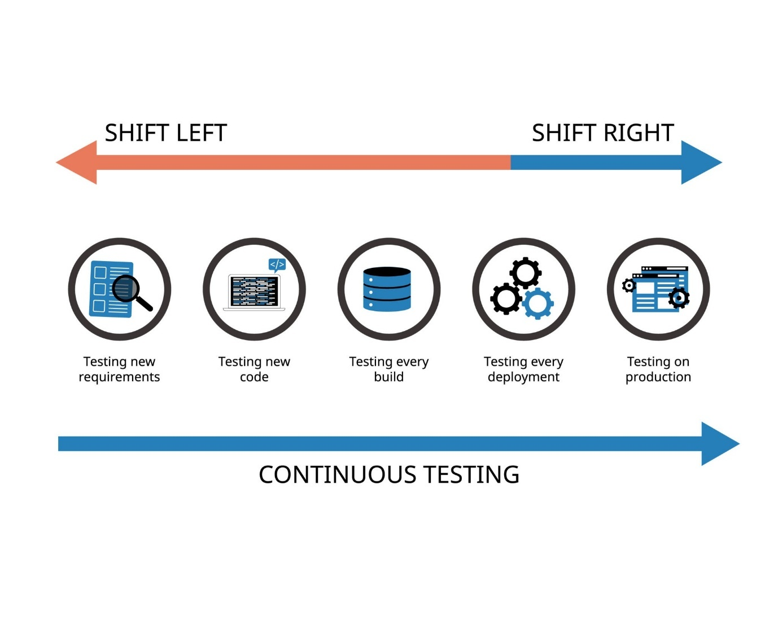
Getty Images
Key Responsibilities:
- Requirement Analysis: Testers analyze User Stories as they are being written to find logic gaps before a single line of code is typed.
- Defining "Done": Testers help define the Definition of Done (DoD). A feature isn't "Done" just because the code is written; it's done when it's tested and bug-free.
- Test Automation: Since Sprints are fast (2 weeks), manual testing everything is impossible. Testers write automated scripts for the Regression Suite as the features are being built.
- Pairing with Developers: An Agile tester often "pairs" with a developer. The developer writes a unit test, and the tester suggests edge cases (like the Boundary Value Analysis we discussed) to make the code more robust.
- Exploratory Testing: While automation handles the repetitive stuff, the tester uses their intuition to "break" the app in creative ways that scripts might miss.
The "Agile Tester" Mindset
Instead of saying "This is a bug, fix it," an Agile tester says "How can we prevent this bug from happening in the first place?"

- What is verification and validation?
Ans) In software testing, Verification and Validation are the two pillars of the V-Model. While they are often used interchangeably, they represent two fundamentally different questions about the software development process.

1. The Core Difference
- Verification: "Are we building the product right?"
- Validation: "Are we building the right product?"

2. Verification (The Process Check)
Verification is a static process. It happens before the code is actually executed. It involves checking documents, design, and code structure to ensure they meet the pre-defined specifications.
- Activities: Reviews, Walkthroughs, Inspections, and Desk-checking.
- When it happens: Throughout the entire development lifecycle (STLC).
- Focus: Does the code match the design? Does the design match the requirements?
- Example: You are building your "BookedIn" project. You review your database schema (PostgreSQL) to ensure it includes all the fields required for the "AI Recommendations" feature before you start coding.

3. Validation (The Product Check)
Validation is a dynamic process. It involves actually running the software and interacting with it to ensure it meets the user's needs and expectations.
- Activities: Unit Testing, Integration Testing, System Testing, and User Acceptance Testing (UAT).
- When it happens: After the verification of code is complete.
- Focus: Does the software actually solve the user's problem? Is it easy to use?
- Example: You have finished coding the "Karshak" farmer-to-consumer app. You give it to a farmer to use. If they find the interface confusing, the app fails Validation, even if the code was "Verified" to be bug-free.

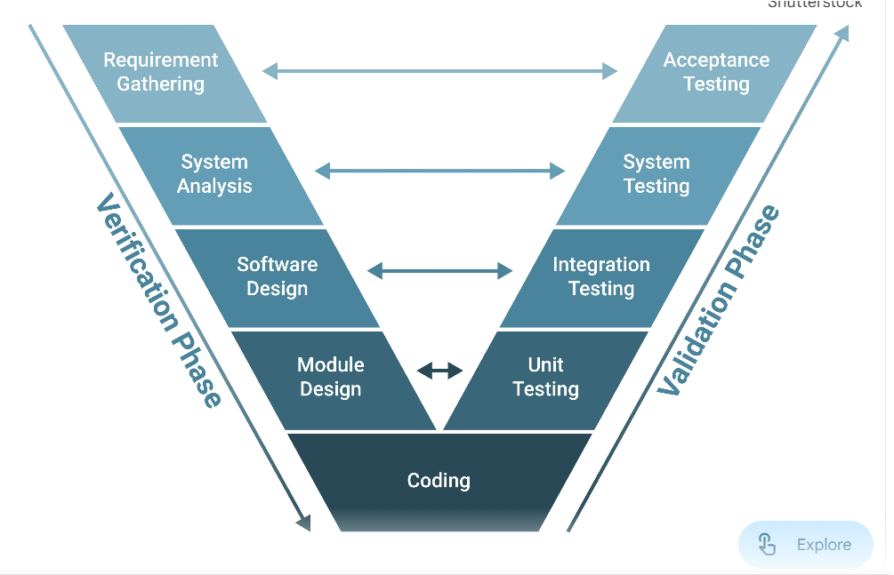

4. Comparison Table
Feature | Verification | Validation
Nature | Static (No code execution) | Dynamic (Code execution)
Goal | To ensure consistency and compliance | To ensure customer satisfaction
Method | Reviews and Inspections | Testing the final product
Order | Comes first | Follows verification
Example | Checking a Test Plan for errors | Running a Regression Suite

5. Practical Scenario: Banking Application
Imagine you are working on a new "Money Transfer" feature for a bank at Cognizant:
- Verification: You attend a meeting to review the "Business Requirements Document" (BRD). You notice that the requirement says "Transfer limit is $10,000" but the design says "$5,000." You catch this error before a single line of code is written. You verified the plan.
- Validation: Once the code is ready, you log into the test environment and try to transfer $10,001. If the system allows it, the feature fails. If the system blocks it but the user interface is so slow that the user gets frustrated, it might pass functional validation but fail User Validation.

- What is a test plan and how does it differ from test design?
Ans) In the Software Testing Life Cycle (STLC), a Test Plan is the strategic "Why" and "When," while Test Design is the tactical "How."
Think of it like planning a trek: the Test Plan is the map, the budget, and the schedule; the Test Design is the specific sequence of steps you take to climb the mountain.

1. Test Plan (The Strategy)
A Test Plan is a high-level document created during the planning phase. It acts as a guide for the entire testing project, ensuring all stakeholders are aligned on the objectives and constraints.
- Goal: To define the scope, approach, resources, and schedule.
- Created By: Test Lead or Project Manager.
- Content: * Scope: What features will be tested (and what will be ignored).
  - Resources: Who is testing? What hardware/software is needed?
  - Schedule: When does testing start and end?
  - Risk Management: What happens if the server goes down or a tester falls ill?
  - Criteria: Entry criteria (when to start) and Exit criteria (when to stop).

2. Test Design (The Blueprint)
Test Design happens after the plan is approved. It involves breaking down the high-level requirements into executable units. This is where you apply the techniques we discussed, like Boundary Value Analysis or Equivalence Partitioning.
- Goal: To create the specific steps required to verify a feature.
- Created By: Testers or QA Engineers.
- Content:
  - Test Scenarios: High-level "what to test" (e.g., Verify Login functionality).
  - Test Cases: Step-by-step instructions with inputs and "Expected Results."
  - Test Data: Specific values used to fill out forms or trigger APIs.
  - Traceability: Linking each test case back to a specific requirement.

3. Key Differences at a Glance
Feature | Test Plan | Test Design
Focus | Strategic (Management) | Tactical (Technical)
Level | High-level overview | Detailed and granular
Main Question | What are we doing and when? | Exactly how do we test this?
Flexibility | Rigid (Changes require approval) | Dynamic (Evolves with the code)
Timing | Initial phase of STLC | Middle phase (after requirement analysis)
Participants | Test Leads, Clients, Managers | Testers, Developers

- What is RTM(Requirement Traceability Matrix)?
Ans) RTM stands for Requirements Traceability Matrix. It is a document (usually a table) that maps and traces user requirements with their corresponding test cases.
Its primary purpose is to ensure that 100% of the requirements are covered by testing and that no "rogue" features have been added that weren't asked for.

1. Why do we need an RTM?
In a large project at a company like Cognizant, you might have 500 requirements and 2,000 test cases. Without an RTM, it’s impossible to know:
- Did we forget to test Requirement #42?
- If Requirement #10 changes, which test cases do we need to update?
- Are we "over-testing" one feature while neglecting another?

2. Components of an RTM
A typical RTM contains the following columns:
- Requirement ID: Unique ID from the Business Requirement Document (BRD).
- Requirement Description: A brief summary of what the feature should do.
- Test Case ID: The ID of the test case(s) designed to verify that requirement.
- Test Status: Pass, Fail, or Not Run (updated during execution).

3. Types of Traceability
- Forward Traceability: Mapping requirements to test cases. It ensures that every requirement is being tested.
- Backward (Reverse) Traceability: Mapping test cases back to requirements. It ensures that you aren't writing unnecessary tests for features that aren't even in the scope.
- Bi-Directional Traceability: A combination of both. This is the industry standard.

4. RTM in the STLC
The RTM is usually started during the Requirement Analysis phase and is continuously updated until the Test Closure phase.
In Jira (which you’ll be using), traceability is often handled automatically. You can "Link" a Bug to a Test Case, and Link that Test Case to a User Story. This creates a digital RTM where you can see at a glance if a requirement is "Ready for Release" or "Blocked by Defects."
Since you've already mastered Verification and Validation, you can think of the RTM as a tool for Verification (ensuring the design covers the requirements) and Validation (proving through test results that the requirement works).

- What are the different types of integration testing?
Ans) In software testing, Integration Testing is the phase where individual modules are combined and tested as a group. The goal is to expose faults in the interaction between these modules (e.g., data passing incorrectly between the UI and the Database).
There are four primary strategies for integration testing, each with its own "flow" of execution.

1. Big Bang Integration
In this approach, all or most of the developed modules are coupled together at once and then tested as a whole.
- How it works: You wait for every developer to finish their module, smash them together, and see if the system runs.
- Pros: Good for very small, simple projects.
- Cons: If a bug occurs, it is incredibly difficult to find which module caused it because everything was integrated at once. It also causes delays since you have to wait for the last module to be finished.

2. Top-Down Integration
Testing starts from the top-level modules (the "User Interface" or "Main Menu") and moves down to the lower-level modules.
- How it works: Since lower-level modules might not be ready yet, we use Stubs. A Stub is a dummy program that simulates a lower-level module by returning a hardcoded response.
- Example: You test the "Book Search" UI. Since the "Database Search" module isn't ready, the Stub just returns a fixed list of 3 books so you can test the UI layout.
- Pros: Catch major design flaws early; provides a working "demo" of the app quickly.

3. Bottom-Up Integration
Testing starts from the lowest-level modules (like database connectors or utility functions) and moves up to the high-level UI.
- How it works: Since the top-level control modules aren't ready, we use Drivers. A Driver is a dummy program that "calls" the module under test and passes data to it.
- Example: You test the "Payment Calculation" logic. Since the UI isn't ready, you write a script (the Driver) to feed it numbers and check if the math is correct.
- Pros: Excellent for catching technical bugs in core logic and data processing.

4. Sandwich (Hybrid) Integration
As the name suggests, this is a combination of Top-Down and Bottom-Up.
- How it works: You test the system from both ends simultaneously. The top-level modules are tested using stubs, and the bottom-level modules are tested using drivers, eventually meeting in the middle (the "Logic" layer).
- Pros: Offers the best of both worlds and is the most common approach for complex, large-scale enterprise systems like the ones you'll handle at Cognizant.

Summary Comparison
Strategy | Direction | Uses | Best For...
Big Bang | All at once | Nothing | Small, fast-track projects.
Top-Down | Top $\rightarrow$ Bottom | Stubs | Validating user flow and UI logic.
Bottom-Up | Bottom $\rightarrow$ Top | Drivers | Validating data processing and APIs.
Sandwich | Both ends | Both | Complex apps like BookedIn or Banking.

- What is UAT(User Acceptance Testing)?
Ans) UAT stands for User Acceptance Testing. It is the final phase of the software testing process before the system is moved to the production environment (released to the real world).
If System Testing is about checking if the software is bug-free, UAT is about checking if the software is useful and meets the business requirements.

1. The Core Objective
In UAT, the actual users (or stakeholders) test the software to see if it can handle real-world scenarios. It answers the ultimate question: "Does this product do what I need it to do to run my business?"
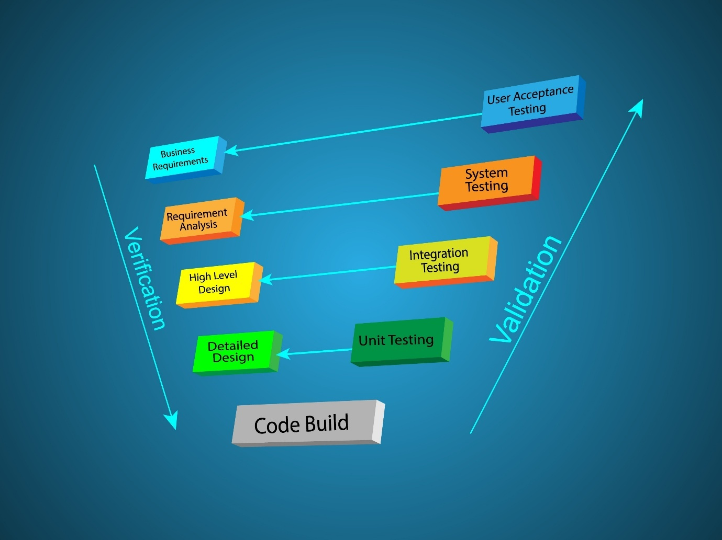
Shutterstock
Explore

2. Who performs UAT?
Unlike other testing phases, UAT is typically not performed by the QA team.
- End Users: The people who will actually use the app daily (e.g., bank tellers for a banking app).
- Subject Matter Experts (SMEs): People who understand the business logic deeply.
- Product Owners: To ensure the vision they had for the product has been realized.
- Client Stakeholders: The people paying for the software.

3. Types of UAT
There are two main "flavors" of UAT depending on who is doing the testing and where:
Alpha Testing
- Where: Performed at the developer’s site (in-house).
- Who: Internal employees or a dedicated internal test team.
- Goal: To identify any remaining bugs before showing the product to external customers.
Beta Testing (Field Testing)
- Where: Performed at the customer’s site or by the general public.
- Who: A limited number of real end-users.
- Goal: To get feedback on usability and performance in a real-world environment.

4. Key Activities in UAT
- Selection of Test Cases: Users don't test every technical detail; they test Business Use Cases.
- Execution: Users perform tasks like "Create an Account," "Transfer Funds," or "Apply for a Loan."
- Bug Reporting: If a user finds the interface confusing or a button missing, they report it—even if the code technically works.
- The "Sign-Off": This is the most critical part of UAT. Once the users are satisfied, they provide a formal "Sign-Off," which is the legal/managerial green light to go live.

5. UAT vs. System Testing
Feature | System Testing | UAT
Performed By | QA / Testers | End Users / Clients
Focus | Technical Requirements (Bugs) | Business Requirements (Usability)
Environment | Test/Staging Environment | UAT/Pre-production Environment
Example | Testing if the "Submit" button saves data to the SQL database. | Testing if the "Submit" form has all the fields a bank manager needs.
- What is Exploratory testing?
Ans) Exploratory Testing is a "simultaneous" approach to software testing where the tester learns about the application, designs test cases, and executes them all at the same time.
Unlike scripted testing—where you follow a pre-written document step-by-step—exploratory testing relies on the tester’s intuition, experience, and creativity to find bugs that formal scripts might miss.

1. How it Works
In exploratory testing, the next test you perform is often determined by what you discovered in the previous test. It follows a "test-and-learn" loop:
- Learn: Explore a feature to see how it behaves.
- Design: Formulate a "What if?" scenario (e.g., "What if I click 'Pay' and immediately refresh the page?").
- Execute: Perform the action.
- Observe: Check the result. If it's a bug, report it; if not, use the knowledge to design a deeper test.

2. Key Characteristics
- Unscripted: There are no pre-defined test cases.
- Intellectual: It requires a "detective" mindset.
- Time-Boxed: It is often performed in "sessions" (e.g., a 90-minute session focused on the "Search" module).
- High Bug Yield: It is highly effective at finding edge-case bugs and usability issues that manual scripts overlook.

3. When to Use It?
Exploratory testing is not meant to replace scripted testing, but to complement it. It is best used:
- Early in the STLC: When requirements are still vague or the code is new.
- During Agile Sprints: When there isn't enough time to write 100+ formal test cases for every small change.
- After Scripted Testing: To "double-check" the app before a release.
- Critical Bug Investigation: When a bug is reported in production and you need to find its root cause by trying different variations.

4. Scripted vs. Exploratory Testing
Feature | Scripted Testing | Exploratory Testing
Approach | Pre-defined (Plan first, then execute) | Spontaneous (Learn and execute together)
Focus | Confirmation (Does it meet specs?) | Investigation (What can go wrong?)
Documentation | Heavy (Test plans, cases, scripts) | Light (Session notes and bug reports)
Skill Required | Basic (Following instructions) | High (Deep domain and technical knowledge)
Automation | Highly suitable for automation | Nearly impossible to automate

- How would you test a shopping cart with multiple products, coupons access.
Ans) Testing a shopping cart with multiple products and coupon logic is a classic "High Complexity" scenario because of the sheer number of combinations. To ensure full coverage, we apply the black-box techniques we discussed earlier: Equivalence Partitioning, Boundary Value Analysis, and Decision Tables.
Here is how you would structure the test cases:

1. Functional Testing (The Happy Path)
These tests ensure the basic logic of adding and calculating items works as expected.
- Multi-Product Calculation: Add 3 different items with different tax rates. Verify that the Subtotal, Tax, and Total are calculated correctly.
- Quantity Updates: Change the quantity of one product from 1 to 5. Verify the price updates instantly.
- Product Removal: Remove one product from a cart of three. Verify that the total is recalculated and the coupon (if applied) still holds if the conditions are met.
- Persistent Cart: Log out with items in the cart, then log back in. The items should still be there.

2. Coupon & Discount Logic (Decision Table)
Coupons are the most common source of bugs in e-commerce. You must test the "Conditions."
Test Case | Scenario | Expected Result
Valid Coupon | Apply a 10% discount code on a valid total. | Discount is deducted; Total is updated.
Minimum Spend | Apply a "$50 off" coupon on a $40 cart. | Error: "Minimum spend of $50 required."
Category Specific | Apply a "Books" coupon to a cart containing "Electronics." | Error: "Not applicable to items in your cart."
Expiry Date | Apply a coupon that expired yesterday. | Error: "Coupon has expired."
Double Dipping | Try to apply two different coupons to one order. | System should either block the second or apply the "best" one based on policy.

3. Boundary Value Analysis (BVA)
Testing the limits of the shopping cart system.
- Max Quantity: If the limit per item is 10, try ordering 1, 10, and 11.
- Zero/Negative Quantity: Try to manually type "-1" or "0" in the quantity box via the keyboard.
- Empty Cart: Attempt to navigate to the "Checkout" page when the cart is empty. The system should redirect you to the home page or show a "Cart is empty" message.
- Inventory Limit: If there are only 2 books left in stock, try to add 3 to the cart.

4. Edge Cases (Exploratory Testing)
This is where you use your "tester intuition" to find weird bugs.
- The "Back" Button: Apply a coupon, go to the payment page, then click the browser's "Back" button to add another item. Does the coupon still apply to the new total?
- Session Timeout: Leave items in the cart for 24 hours. Does the price update if the product's price changed overnight?
- Currency/Decimal Check: Test with items priced at $10.99 and $5.55 to ensure there are no rounding errors in the final cent calculation.
- Multiple Tabs: Open the cart in two different browser tabs. Add an item in Tab 1 and see if Tab 2 reflects the change.

5. Non-Functional Testing
- Performance: Does the cart take more than 2 seconds to calculate the total when 50 different items are added?
- Security: Can a user "Inspect Element" and change the price of the item to $0.01 before clicking checkout? (This is a critical security test for the backend).

- You find a critical bug one day before the release, what would you do?
Ans) Finding a Critical Bug (S1/P1) just 24 hours before a release is a high-pressure situation that requires a calm, systematic approach. In a professional environment like Cognizant, you must balance technical urgency with clear communication.
Here is the exact step-by-step "Crisis Management" workflow:

1. Immediate Validation & Documentation
Before raising the alarm, you must ensure the bug is real and reproducible to avoid a "false fire."
- Reproduce it: Try to trigger the bug on different browsers or devices to see if it’s environment-specific.
- Isolate the cause: Determine if it’s a frontend crash, a backend API failure, or a database issue.
- Log it in Jira immediately: Use the highest Severity (S1) and Priority (P1). Attach screenshots, video recordings, and logs so the developer doesn't have to ask "how did this happen?"

2. The "War Room" Communication
In an Agile environment, you don't keep this a secret. You must immediately inform the stakeholders.
- Notify the Lead & Product Owner: Send an urgent message or call a quick "Sync" meeting.
- Be Objective: Don't blame anyone. State the facts: "I've found a critical issue in the payment gateway that prevents users from completing checkout. It is reproducible 100% of the time."
- Assess the Impact: Explain exactly what is at risk. Is it a security breach, a complete system crash, or data loss?

3. The Decision-Making Phase
The team (Lead, PO, and Devs) will evaluate three possible paths:
Option | Action | Risk
Hotfix & Release | Devs work overnight to fix it; QA re-tests immediately. | High risk of "Regression" (fixing one thing breaks another).
Feature Toggle | Disable the specific broken feature and release the rest. | The release goes on, but with a "Coming Soon" label on that feature.
Go/No-Go: Abort | Postpone the entire release until the bug is fixed. | Business impact (delay), but prevents a PR disaster.

4. The Tester’s Role During the Fix
If the team decides to fix it:
- Collaborate: Work closely with the developer as they code the fix.
- Impact Analysis: Determine which other modules are connected to the fix.
- Sanity & Regression Testing: Once the fix is delivered, don't just test the bug. Run a quick Regression Suite on the surrounding features to ensure the "Hotfix" didn't break anything else.

5. Post-Release: Root Cause Analysis (RCA)
Once the fire is out, the team must hold a Retrospective to ensure this doesn't happen again.
- Why was this bug missed during the regular test cycles?
- Was it a lack of Boundary Value Analysis?
- Do we need to add an automated test for this specific scenario in our Regression Suite?

- How to test ecommerce checkout process?
Ans) Testing an e-commerce checkout process is a critical task because it involves the "Money Path." Any failure here directly results in lost revenue and customer frustration. To test this effectively, you should break it down into functional stages: Shipping/Address, Payment, and Order Confirmation.

1. Shipping & Address Validation
This stage ensures the system knows where to send the product and calculates costs accordingly.
- Address Accuracy: Test with valid and invalid pin codes/zip codes. Ensure the city and state auto-populate correctly if that feature exists.
- Shipping Methods: If the user selects "Express Shipping," verify the delivery date and shipping fee update in the order summary.
- International Shipping: If the app only ships within India (for example), verify that selecting "United States" triggers an error message.
- Boundary Value Analysis (BVA): Test address fields for character limits (e.g., a very long street name or a name with only 2 characters).

2. Payment Gateway Testing
This is the most sensitive part of the process.
- Payment Methods: Test every integrated method (Credit/Debit Cards, UPI, Net Banking, Digital Wallets).
- Success Scenario: Use test card numbers (provided by gateways like Razorpay or Stripe) to ensure a successful transaction redirects to the "Thank You" page.
- Failure Scenarios:
  - Incorrect Details: Enter the wrong CVV or an expired date.
  - Insufficient Funds: Simulate a declined transaction to ensure the user is prompted to try another method.
  - Timeout/Cancellation: What happens if the user closes the payment tab mid-transaction? The system should not deduct money and should keep the items in the cart.
- Security: Ensure that the CVV and Card Number are masked ($****$) and that the page is running on HTTPS.

3. Order Logic & Calculations
This ensures the math behind the purchase is 100% accurate.
- Total Calculation: Verify: $Subtotal + Shipping + Taxes - Discounts = Final Total$.
- Coupon Application: (As we discussed earlier) ensure the discount applies correctly to the total before the payment is initiated.
- Inventory Check: If a user buys the last 2 books in your BookedIn store, ensure the product page updates to "Out of Stock" immediately after the order is placed.

4. Post-Checkout Verification
Testing doesn't end when the "Pay" button is clicked.
- Order Confirmation: Verify that an Order ID is generated and displayed.
- Communication: Check if a confirmation Email and SMS are sent with the correct order details.
- Database Integrity: (White-box check) Ensure the order is recorded in the backend database with the status "Success" or "Pending."
- Account History: Log into the user profile and verify the new order appears in the "My Orders" section.

5. Non-Functional & Edge Cases
- Concurrency: What happens if two people buy the last remaining item at the exact same millisecond?
- Interrupt Testing: What happens if a phone call comes in or the internet disconnects during the "Processing" stage?
- Browser "Back" Button: Ensure that clicking "Back" after a successful payment doesn't allow the user to submit the payment again (Duplicate Charge).
Checkout Step | Key Technique | Critical Bug to Look For
Address | BVA / ECP | Shipping fee not updating for different regions.
Payment | Negative Testing | System accepting an expired credit card.
Order Summary | Decision Table | Taxes not being calculated on the discounted price.
Confirmation | Functional | Email not sent or containing wrong item details.

- What is the difference between Error, Bug, Defect, and Failure?
Ans)
- Error: Mistake made by the developer while coding
- Bug/Defect: The manifestation of the error in the software
- Failure: When the defect is encountered by the end-user
Flow: Human makes Error → Creates Defect in code → Causes Failure when executed
- How do you prioritize test cases when time is limited?
Ans)
- Critical Path: Test main business flows first
- Risk-Based: Focus on high-risk areas
- Frequently Used: Test features used most by users
- Recently Changed: Test new/modified code
- Past Defects: Areas with history of bugs
Create test priority matrix:
- P1: Must execute (critical flows)
- P2: Should execute (important features)
- P3: Could execute (if time permits)
- Describe your approach to testing a new feature from scratch.
Ans)
- Understand Requirements: Review user story, acceptance criteria
- Ask Questions: Clarify ambiguities with BA/PO
- Identify Test Scenarios: Positive, negative, edge cases
- Write Test Cases: Detailed steps, data, expected results
- Review: Get test cases reviewed by peers
- Prepare Test Data: Create necessary test data
- Environment Check: Verify test environment is ready
- Execute Tests: Run test cases, document results
- Report Bugs: Log any defects found
- Retest: Verify bug fixes
- Regression: Ensure no impact on existing features
- Sign-off: Provide test completion report

